Data Lake Exploration & Optimization
📘 Project Documentation

Table of Contents
- Project Statement
- Project Overview
- Prerequisites
- Project Objectives
- Architecture Diagram
- ER Diagram
- Azure Resources Used for the Project
- Tools Used
- How It Works
- Execution Overview
- Practical Implementation on Azure Portal
- Analysis Results
- Implementation-Tasks Performed
- Successful Output Generated
- Strategies that can be used in Optimising the process
- Conclusion

1. Project Statement
The main goal of this project is to explore and optimize data stored in an Azure Data Lake using PySparkSQL within Azure Databricks. By leveraging Databricks, we can perform seamless data ingestion, transformation, querying, and visualization at scale.
This project demonstrates how organizations can build an efficient data analytics pipeline where raw data is ingested into a Data Lake, processed using PySparkSQL, optimized with Delta format for performance, and then visualized for decision-making.

2. Project Overview
This project walks through the end-to-end process of building a data analytics workflow on Azure. The major steps include:
- Data Ingestion: Loading CSV data (employees.csv) into Azure Data Lake Storage (ADLS).
- Storage Mounting: Connecting ADLS with Azure Databricks using secure authentication (SAS token).
- Exploration with PySparkSQL: Running SQL-like queries on employee data to understand and analyze the dataset.
- Data Optimization: Converting raw data into Delta Lake format for improved performance, ACID transactions, and scalability.
- Analytics & Visualization: Running advanced queries (e.g., top salaries, department statistics, role-based salary averages) and creating charts using Databricks built-in visualization tools.
By the end of the project, we establish a scalable and optimized pipeline for handling structured data in a cloud-native way.

3. Prerequisites
To implement this project, the following requirements are needed:
- Azure Subscription with active credits (student subscription or paid).
- Azure Storage Account with at least one container to hold datasets.
- Azure Databricks Workspace with an active cluster for execution.
- Dataset: employees.csv containing employee records such as ID, name, department, role, salary, etc.
- SAS Token (Secure Access Signature) to mount and connect Databricks with the storage account securely.

4. Project Objectives
The objectives of this project are as follows:
- Connect Azure Databricks with Azure Data Lake Storage using a secure method.
- Perform exploratory data analysis on employee dataset using PySparkSQL queries.
- Optimize data storage by converting raw CSV into Delta Lake format (Bronze → Silver layers).
- Generate valuable insights such as:
  - Top employees with highest salaries.
  - Department-wise employee distribution.
  - Average salaries per role.
  - Trends in employee data for analytics.
- Visualize results using Databricks charts for better understanding and presentation.

5. Architecture Diagram
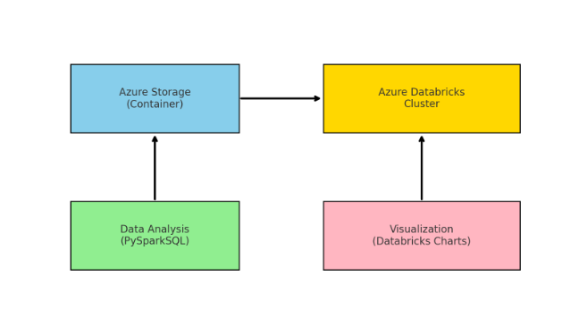

6. ER Diagram
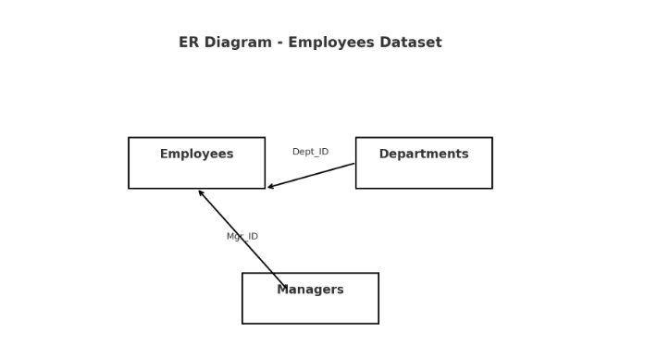

7. Azure Resources Used for the Project
- Azure Storage Account: sivagamistudentstorage
- Container Name: mycontainer (stores employees.csv)
- Azure Databricks: Workspace and Cluster (used for computation and query execution).
- Azure Data Lake: Serves as the central repository for raw and optimized data.

8. Tools Used
- Azure Portal – For provisioning and managing cloud resources (Storage, Databricks).
- Azure Databricks – For big data processing, analytics, and machine learning.
- PySparkSQL – For running SQL queries on structured data inside Spark.
- Azure Storage Explorer (Optional) – For managing datasets inside containers.
- Databricks UI – For creating notebooks, running queries, and building visualizations.

9. How It Works
The workflow of this project can be summarized as follows:
- Upload dataset to Data Lake: The employees.csv file is uploaded to the container (mycontainer) inside the storage account.
- Generate SAS token: A secure token is created to allow Databricks to access the storage account.
- Mount storage to Databricks: Using the SAS token, we mount the container into the Databricks file system (DBFS).
- Read and Explore Data: Load the dataset into a Spark DataFrame and run PySparkSQL queries for analysis.
- Data Optimization: Store processed data in Delta Lake format to support ACID transactions and better query performance.
- Bronze → Silver Architecture:
  - Bronze Layer: Raw ingested CSV data.
  - Silver Layer: Cleaned and optimized Delta tables.
- Analytics & Visualization: Queries are run to derive insights and Databricks’ visualization features are used to generate charts.

10. Execution Overview
- Data Source: Employee dataset (employees.csv) stored in Data Lake.
- Storage: Azure Blob Storage container (mycontainer).
- Processing Engine: Azure Databricks cluster running PySparkSQL.
- Optimization: Data converted to Delta Lake format for performance.
- Visualization: Databricks notebook charts (bar chart, pie chart, etc.) created from SQL query outputs.

11. Practical Implementation on Azure Portal
The practical steps carried out on Azure Portal and Databricks are:
- Create Storage Account → Add a container (mycontainer).
- Upload Dataset → Place employees.csv in the container.
- Create Databricks Workspace → Launch Databricks and set up a cluster.
- Generate SAS Token → From the storage account for authentication.
- Mount Storage in Databricks → Use the SAS token to mount the container.
- Load Data in Notebook → Read employees.csv into Spark DataFrame.
- Run SQL Queries → Examples:
  - Top 10 highest salaries.
  - Average salary by department.
  - Role-wise statistics.
- Convert to Delta Format → Save optimized data in Silver layer.
- Visualize Data → Create charts (bar, pie, histogram) within Databricks.

Step 1: Set Up Azure Databricks
- Created Databricks workspace and cluster in Azure Portal.
- Started cluster before working.

📸 Screenshot: Databricks Workspace
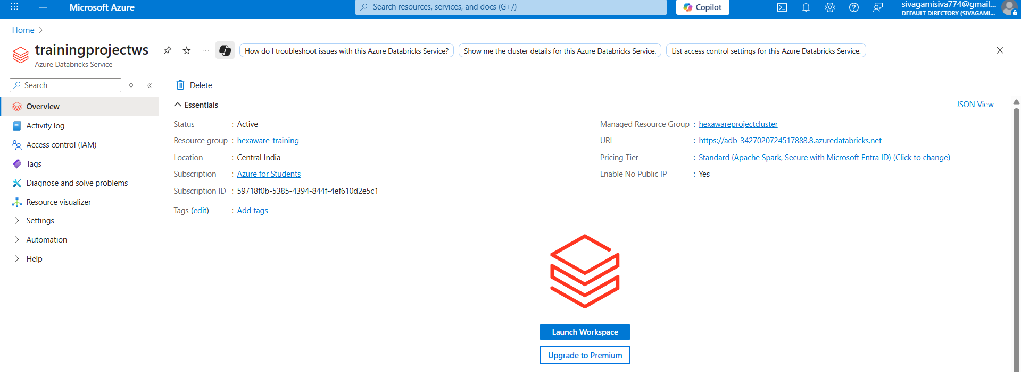
📸 Screenshot: New Notebook Creation
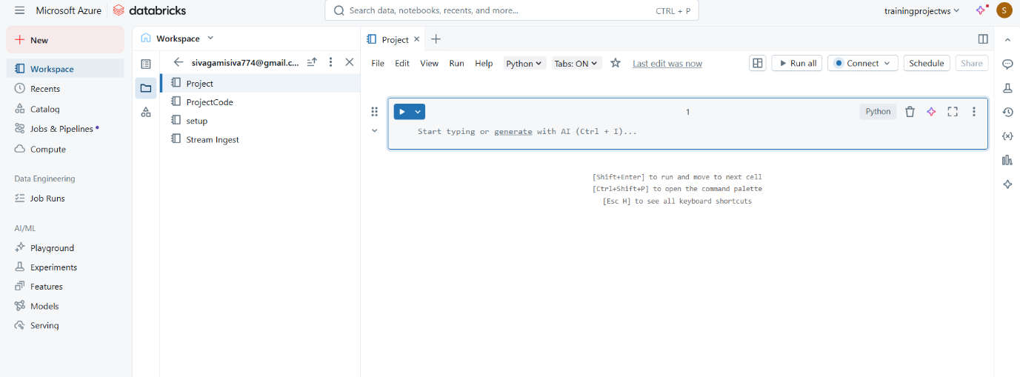
📸 Screenshot: Cluster Running
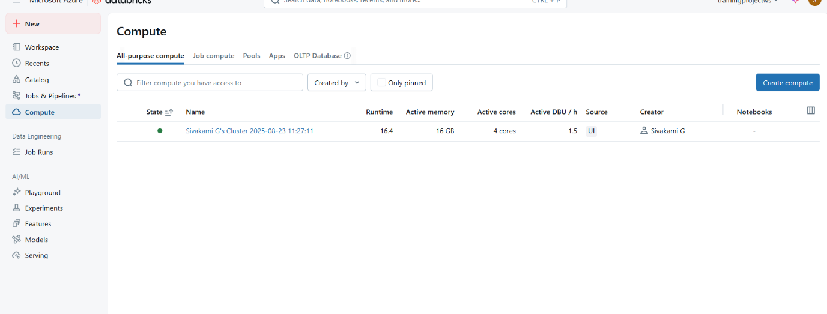

Step 2: Create Azure Storage Account & Container
- Created storage account: sivagamistudentstorage.
- Inside it, created container: mycontainer.
📸 Screenshot: Storage Account Created
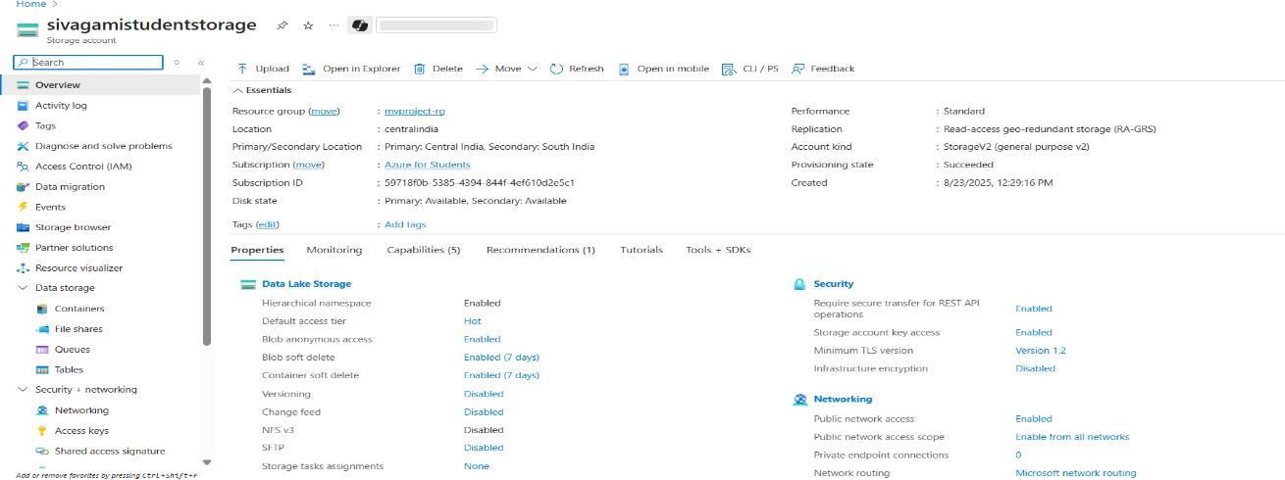
📸 Screenshot: Container Created
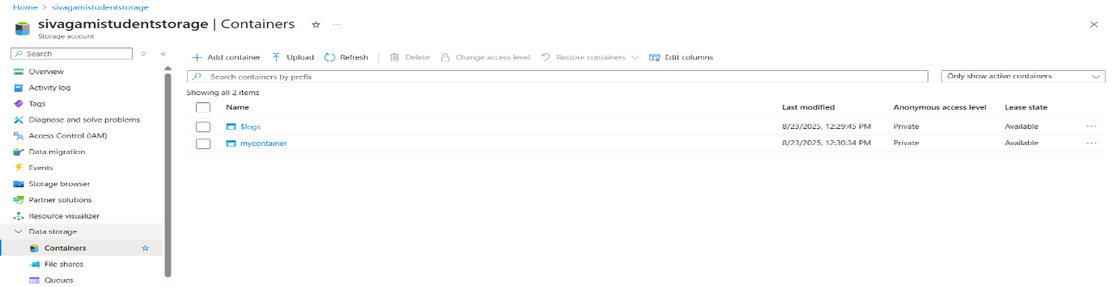

Step 3: Upload Dataset
- Uploaded employees.csv file into mycontainer.
📸 Screenshot: employees.csv Uploaded
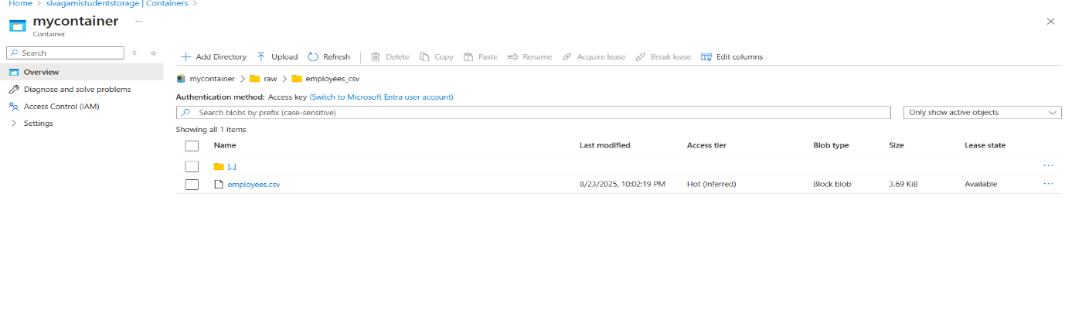

Step 4: Generate SAS Token
- In storage account → Shared Access Signature.
- Enabled all permissions and generated token.
- Copied SAS token string for later use.

📸 Screenshot: SAS Token Generated
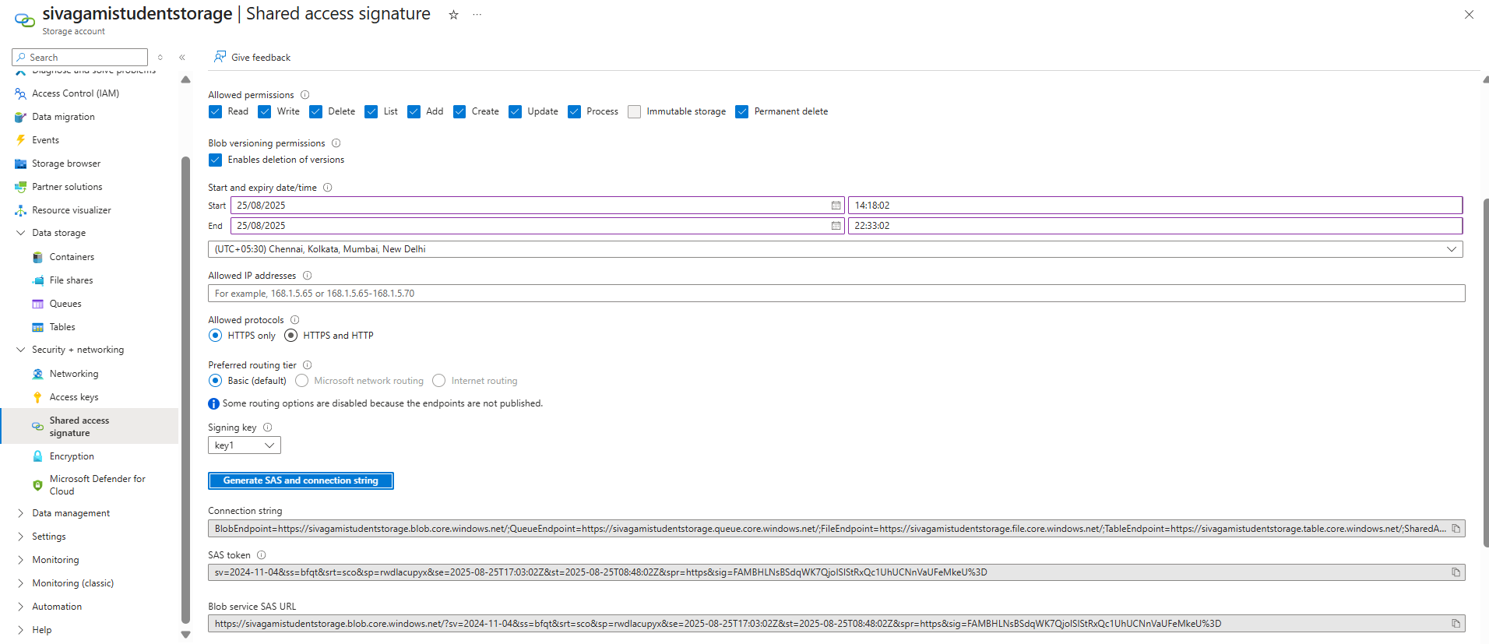

Step 5: Mount Storage in Databricks
- Used PySpark to mount container using SAS token.
📸 Screenshot: Mounting Code in Databricks
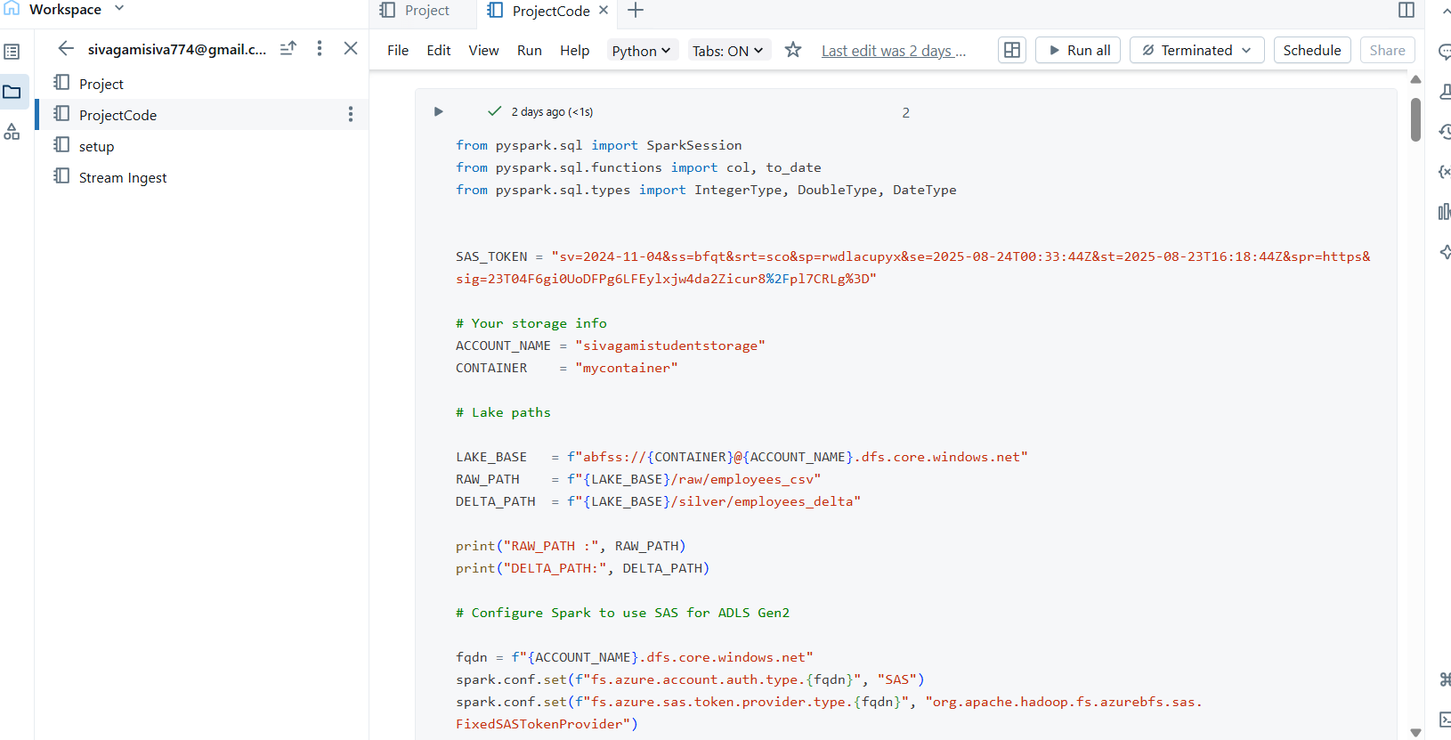
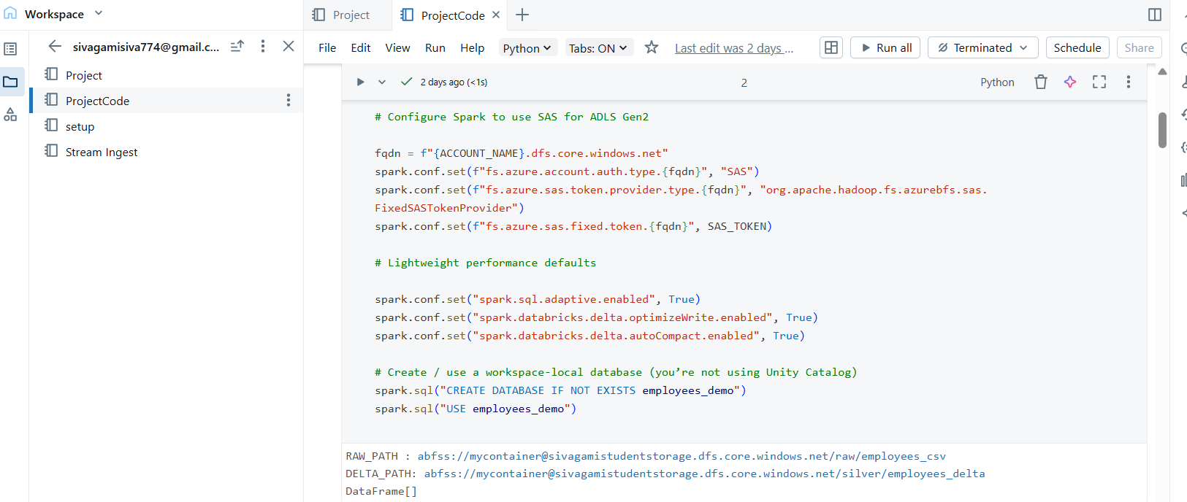

Step 6: Create Employees Delta File
- Converted raw CSV into Delta format.
- Saved into mycontainer/silver/employees_delta.
📸 Screenshot: employees_delta File Created
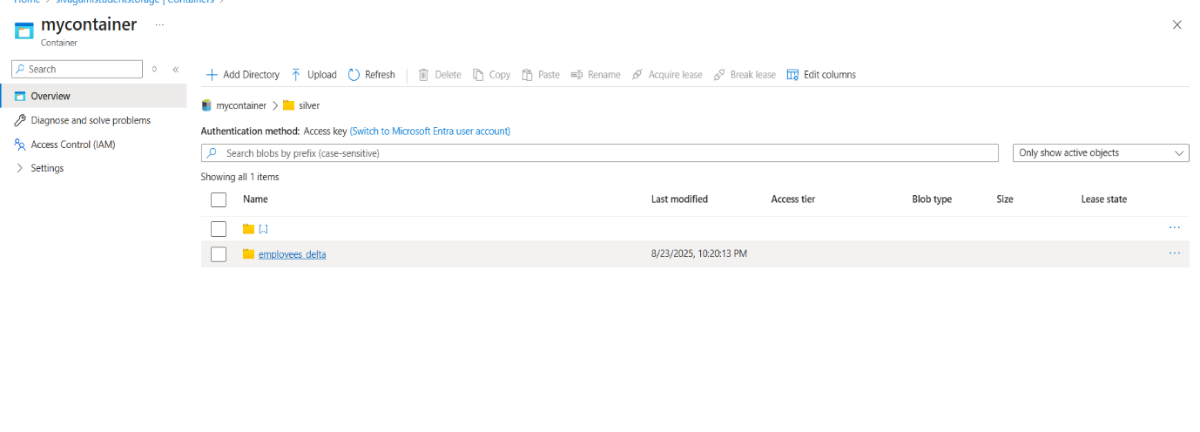

Step 7: Read CSV from Lake
- Used spark.read.csv() to read employees.csv.
📸 Screenshot: Read CSV Code Output
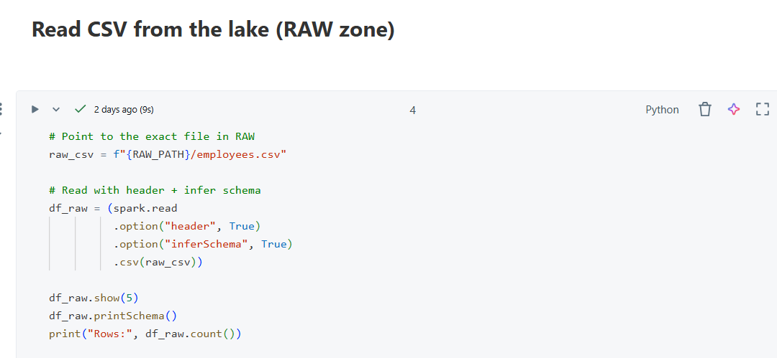
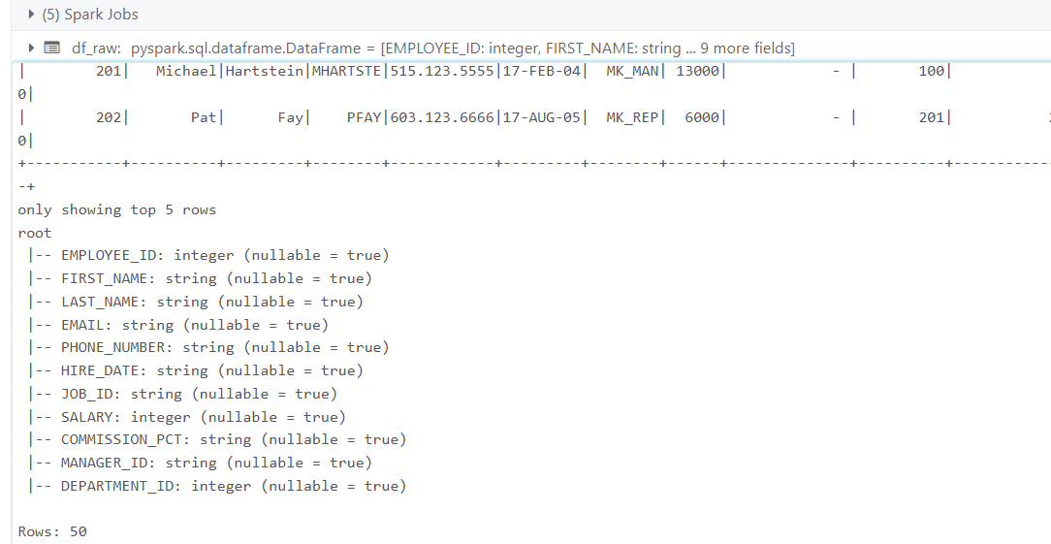

Step 8: Write to File (Delta Format)
- Wrote employees dataset into Delta format for optimization.
📸 Screenshot: Writing to Delta File
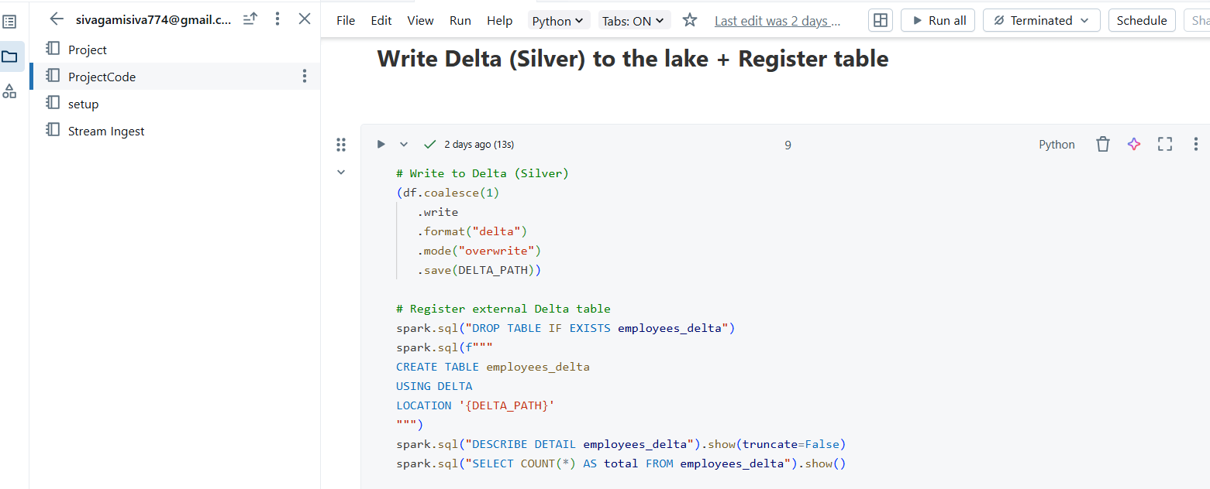

12. Analysis Results
🔹 Query 1: Top 5 Highest Paid Employees
📸 SQL Query + Result
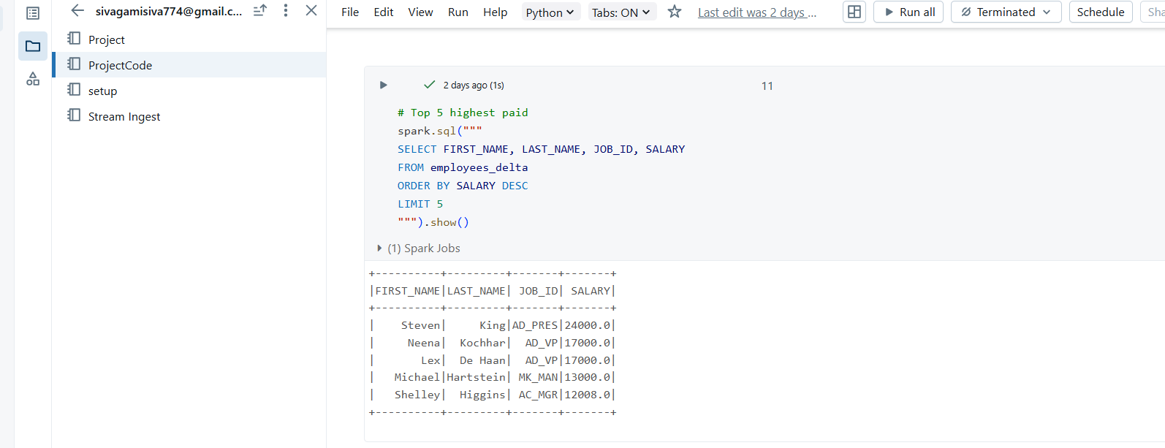

🔹 Query 2: Employees per Department
📸 SQL Query + Result
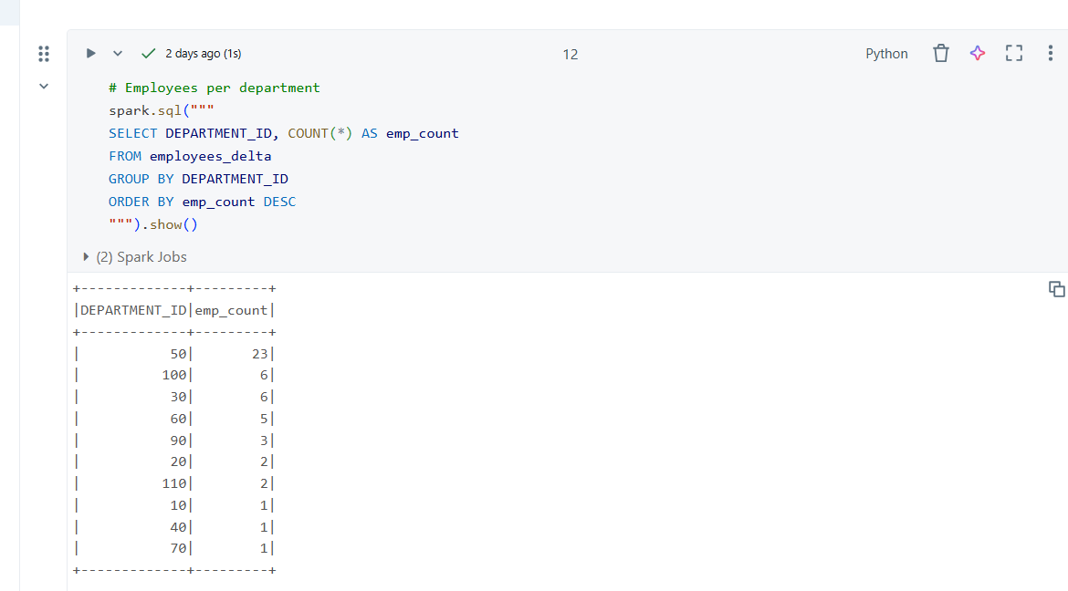
🔹 Query 3: Average Salary by Job Role
📸 SQL Query + Result
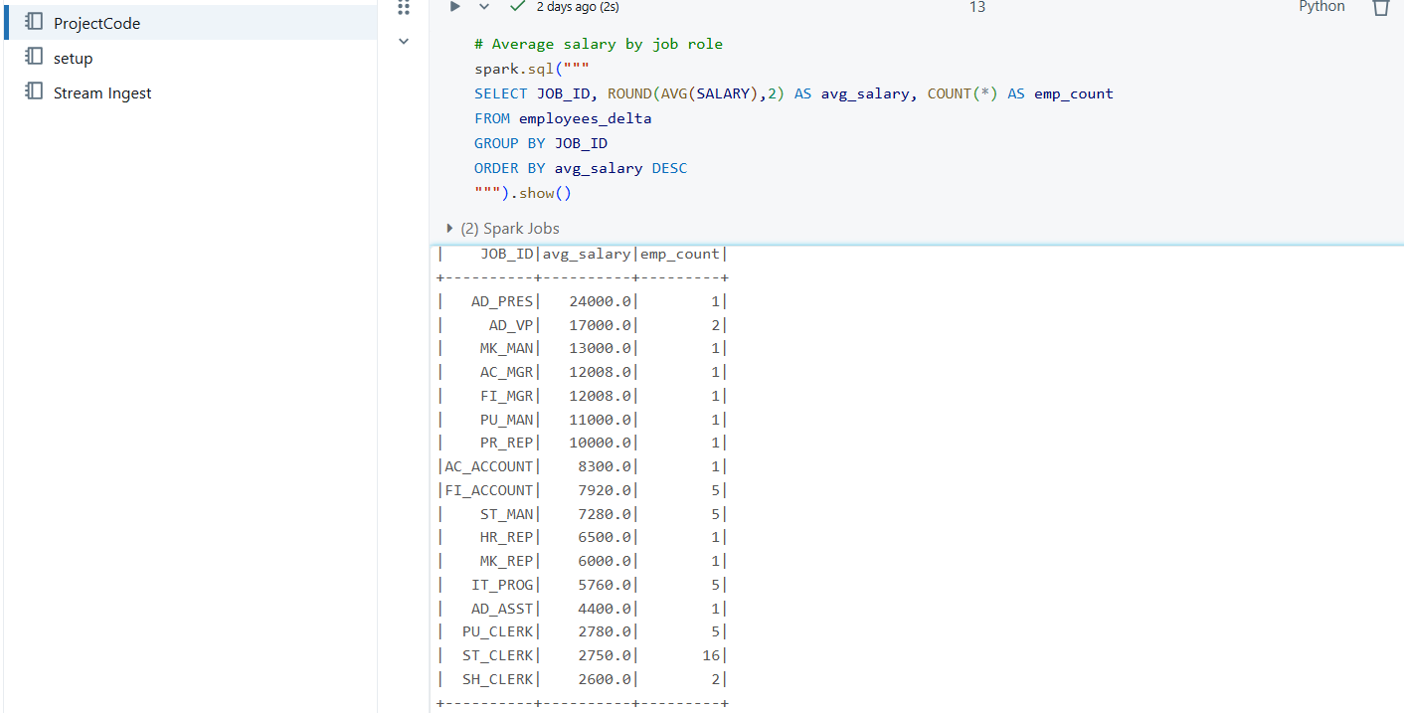

🔹 Query 4: Manager-Employee Counts
📸 SQL Query + Result
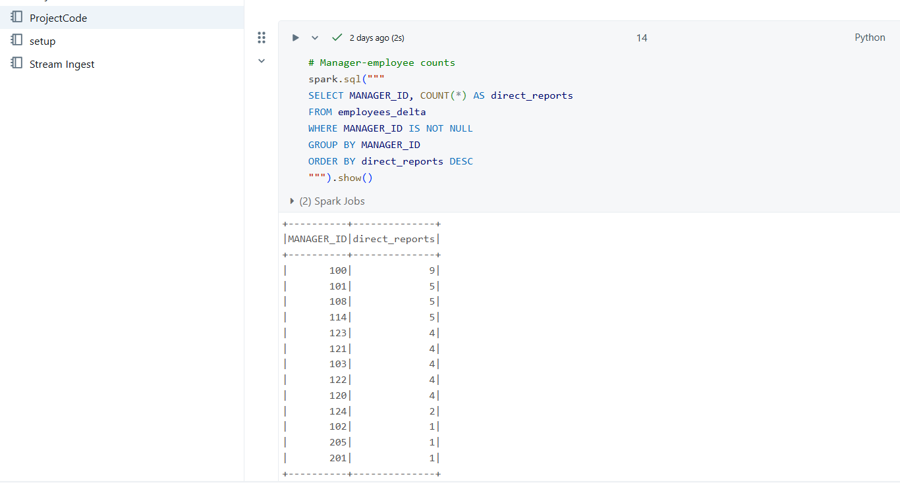

13. Successful Ouput Generated - Chart Visualization
- Used Databricks chart option to visualize employees per department.
📸 Chart Visualization
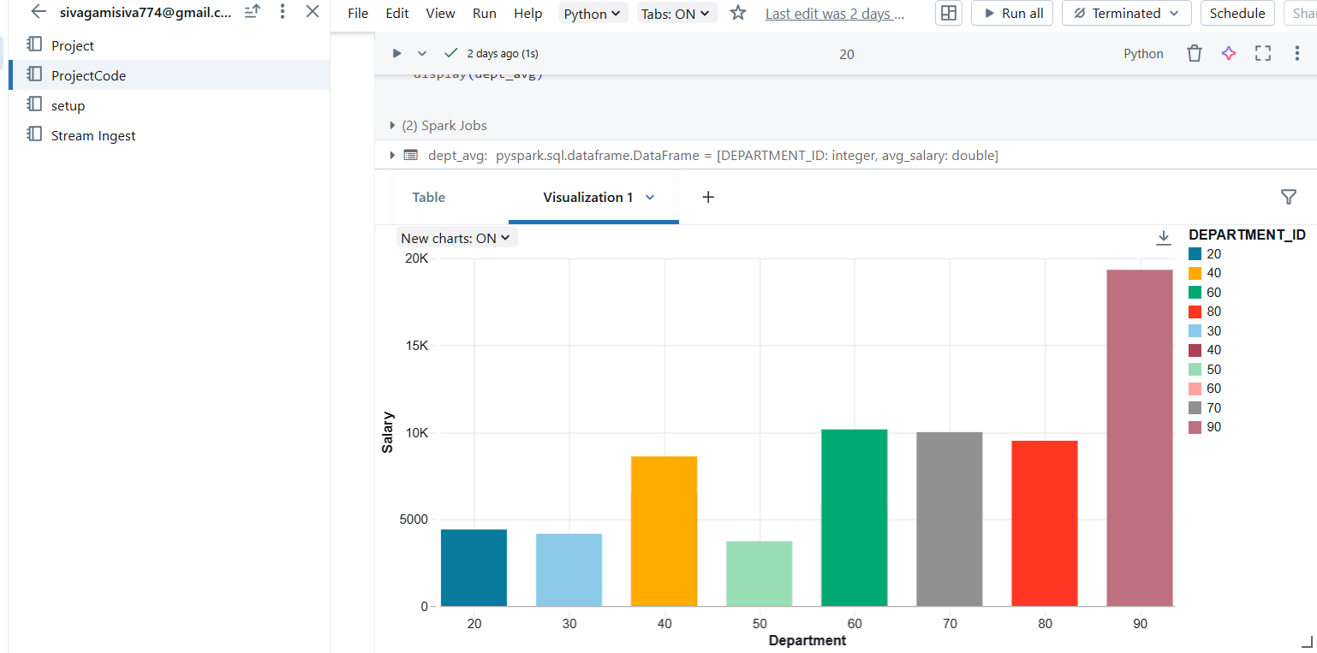
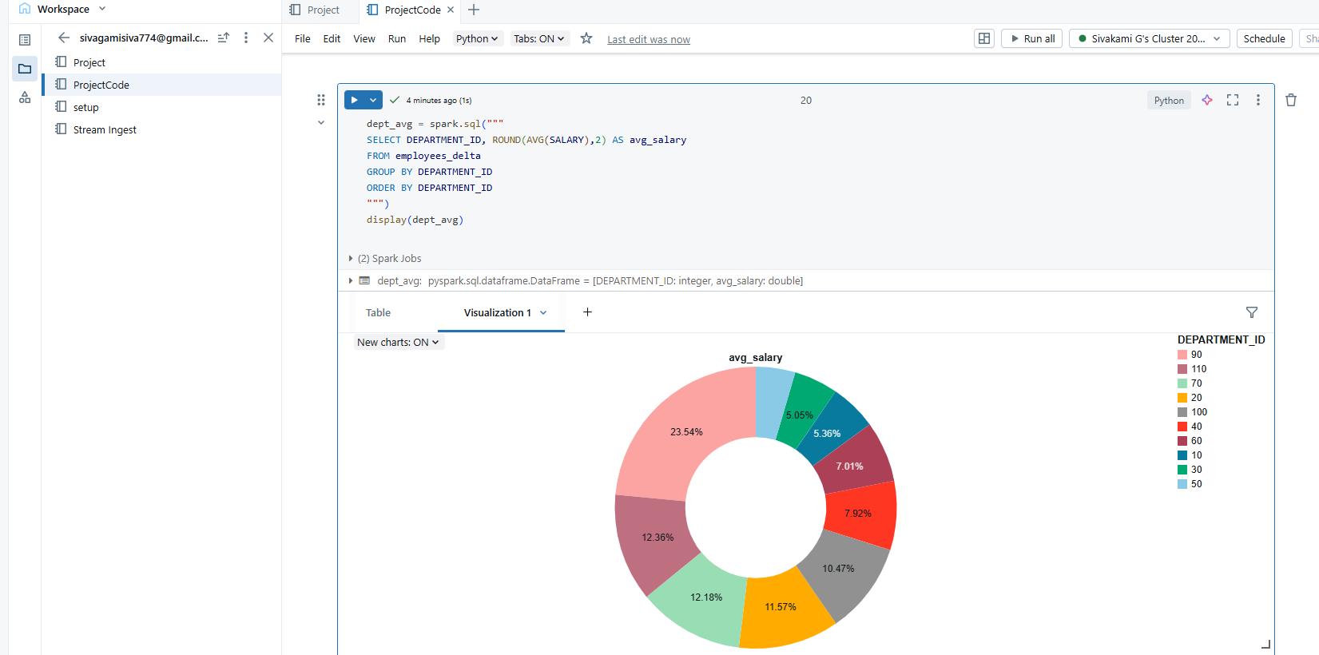

14. Implementation Tasks Performed
- Set up Azure Storage Account and container.
- Uploaded employees.csv dataset.
- Created and configured Azure Databricks Workspace.
- Generated SAS Token for secure access.
- Mounted ADLS to Databricks File System (DBFS).
- Explored dataset with PySparkSQL queries.
- Converted raw data to Delta format (Bronze → Silver).
- Performed analytics and insights extraction.
- Built visualizations inside Databricks notebooks.

15. Strategies that can be used in Optimising the process
- Use Delta Lake Format – Enables ACID transactions, schema enforcement, and faster queries compared to raw CSV/Parquet.
- Partitioning & Bucketing – Organize data by columns (e.g., department, date) for efficient filtering and reduced scan times.
- Caching & Persisting Data – Cache frequently used DataFrames or tables in Databricks memory for faster iterative queries.
- Optimize File Sizes – Compact small files into larger ones to reduce overhead and improve Spark performance.
- Leverage Z-Ordering & Indexing – Use Databricks Z-ORDER and indexes for efficient query pruning and faster lookups.

16. Conclusion
This project successfully demonstrated how to:
- Connect Azure Databricks with Data Lake.
- Explore and optimize data using PySparkSQL.
- Perform analytics and generate visual insights.
- Optimize data storage with Delta Lake.
The integration of Databricks and ADLS provided a scalable, efficient, and powerful data analysis environment for real-world data engineering tasks.

